Gabe Quinones
1/30/2026
Building a REST API with Cloud Functions (Node.js)
Cloud Function Gen 2 URL: https://us-central1-sp26-cit50100-scratch-gquinon.cloudfunctions.net/api
Items URL: https://us-central1-sp26-cit50100-scratch-gquinon.cloudfunctions.net/api/items
Item 1 URL: https://us-central1-sp26-cit50100-scratch-gquinon.cloudfunctions.net/api/items/1
Item 2 URL: https://us-central1-sp26-cit50100-scratch-gquinon.cloudfunctions.net/api/items/2
Item does not exist URL: https://us-central1-sp26-cit50100-scratch-gquinon.cloudfunctions.net/api/items/4
Purdue GitHub URL: https://github.itap.purdue.edu/gcquinon/rest-api-lab
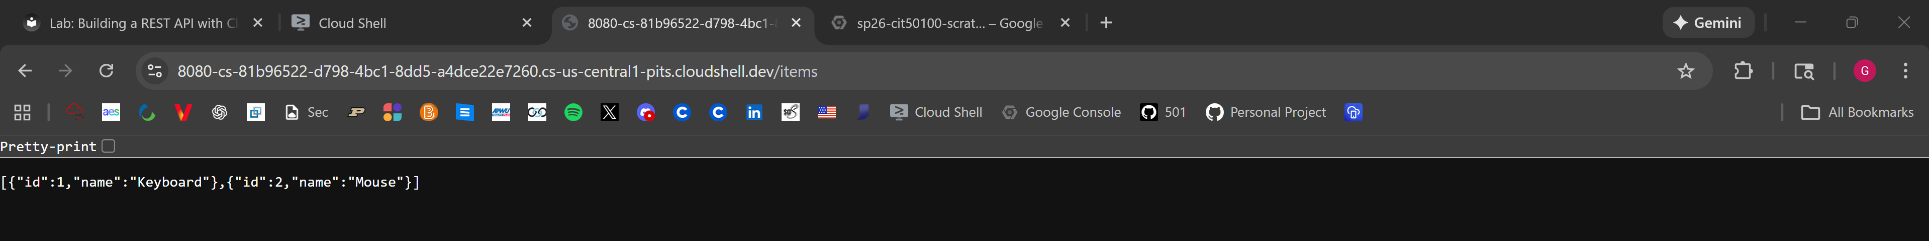
Result of GET All Items through URL link.
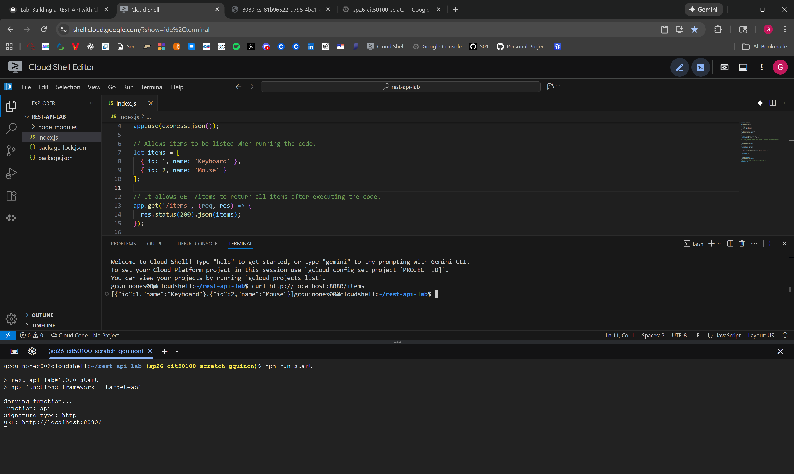
Result of GET All Items through terminal with curl command.
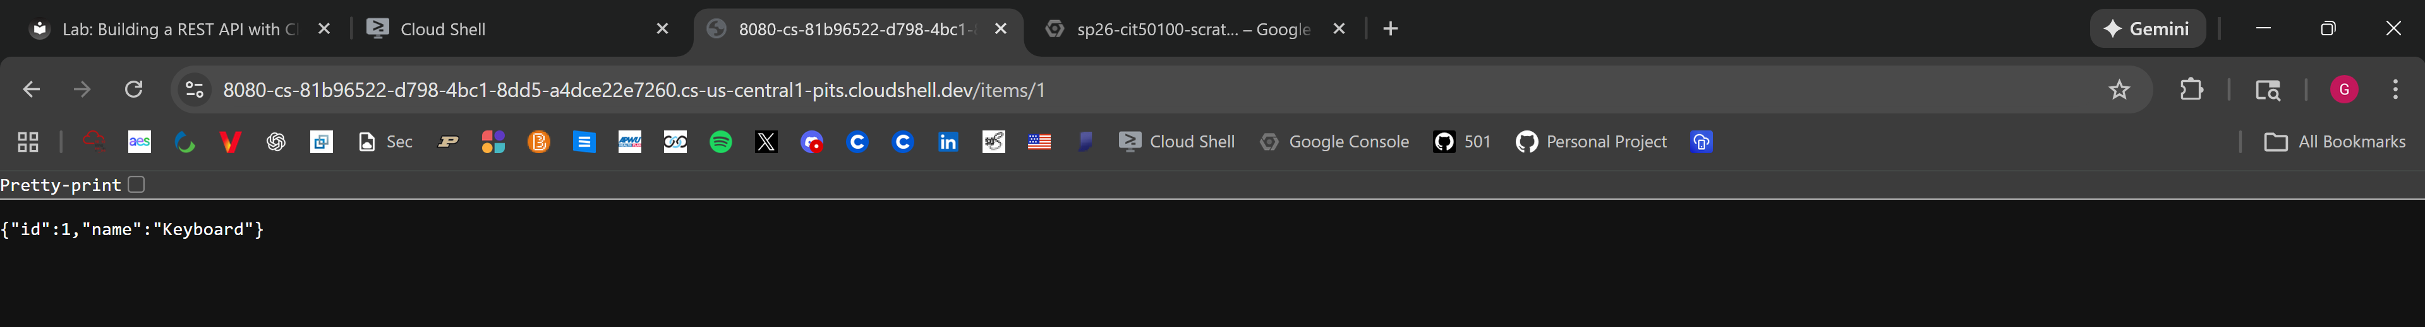
Result of GET Item by ID through URL link.
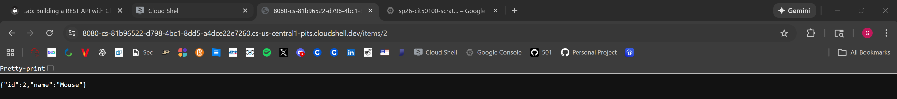
Result of GET Item by ID through URL link.
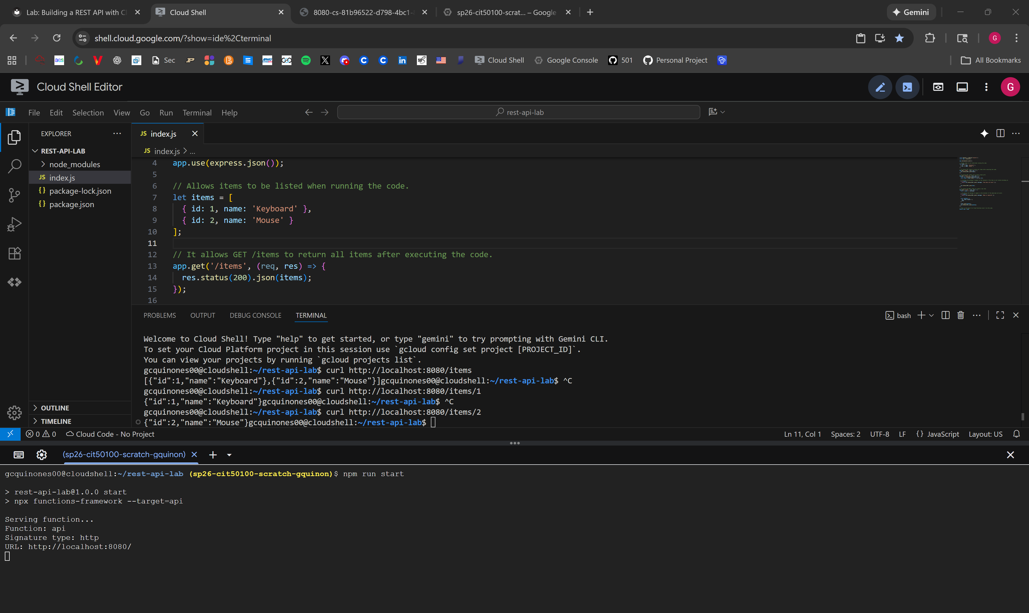
Result of GET Item by ID through terminal with curl command.
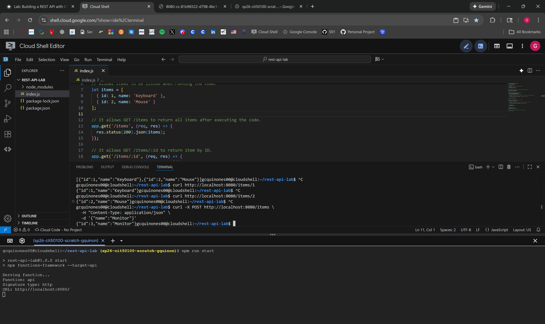
Result of POST a New Item through terminal with curl -X POST command.
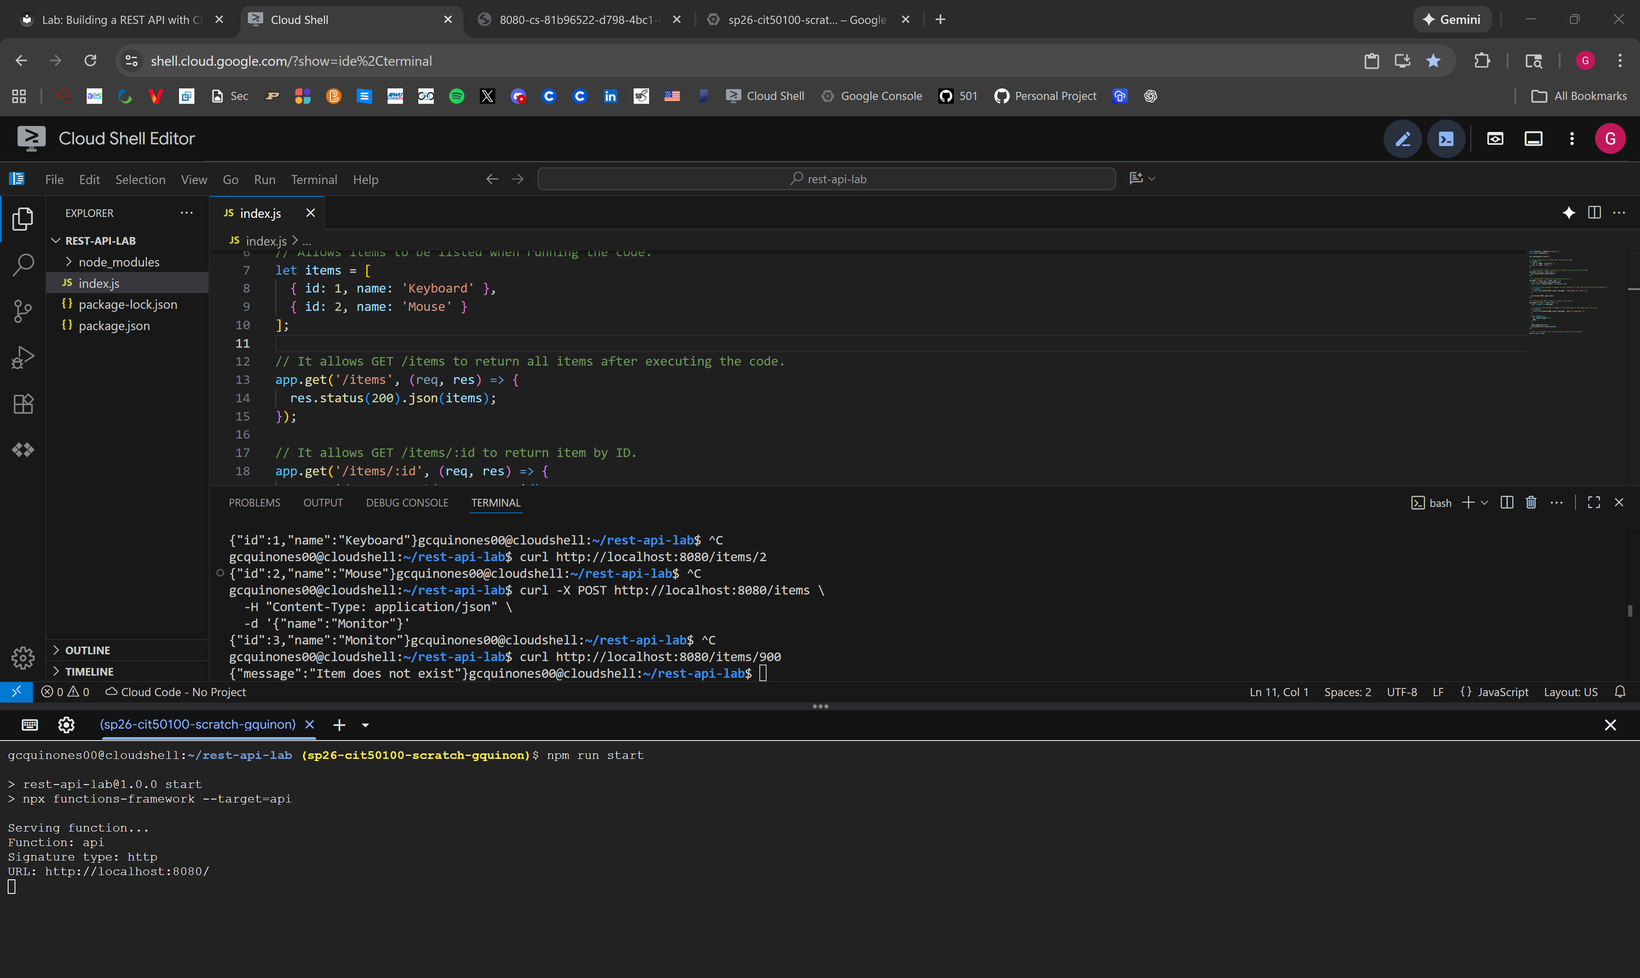
Result of requesting an ID that doesn’t exist through terminal with curl command.
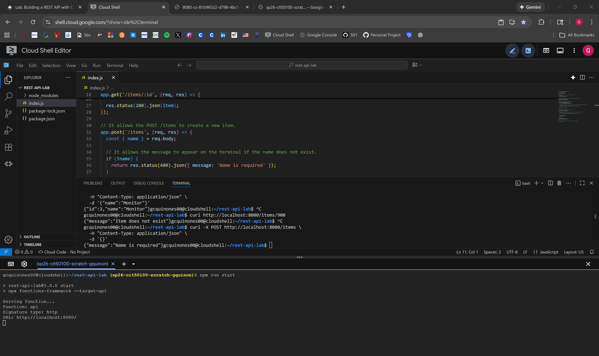
Result of sending a POST request with no name through terminal with curl -X POST command.

